i have created a table with partition using this query
CREATE TABLE [logdata]
WITH (
DISTRIBUTION = HASH ([Operation name]),
PARTITION ( [Time] RANGE RIGHT FOR VALUES
('2023-01-01','2023-02-01','2023-03-01','2023-04-01'))
)
Now i want to delete partition of january from table , how can i?
1.

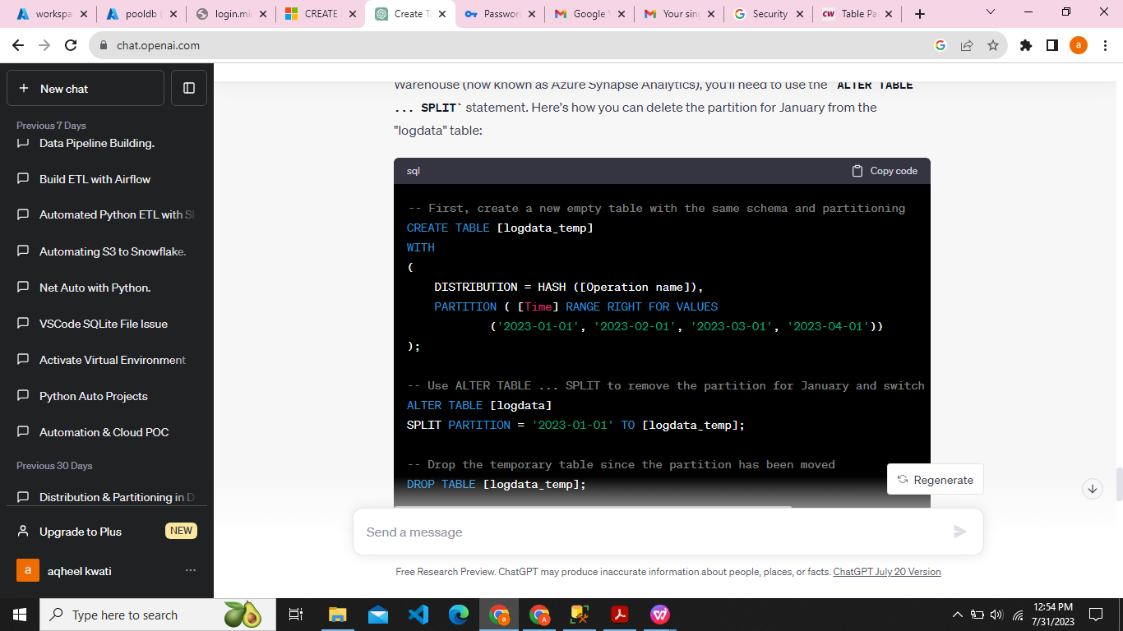
p];
Explanation:

The first step is to create a new temporary table called "logdata_temp" with the same schema and partitioning configuration as the original "logdata" table. We are essentially creating an empty table that will later receive the partition we want to delete.

The second step is to use the ALTER TABLE ... SPLIT statement to remove the partition for January ('2023-01-01') from the "logdata" table. The SPLIT PARTITION clause is used to specify the partition to be removed. The TO [logdata_temp] clause indicates that the partition data will be moved to the temporary table "logdata_temp."

Finally, we drop the temporary table "logdata_temp" since the partition has been successfully moved to it. The "logdata_temp" table now contains the data for January that was previously in the "logdata" table.

Please note that partition management in Azure SQL Data Warehouse (Azure Synapse Analytics) is done through partition switching, which is a metadata operation and is typically more efficient and faster than physically moving data. The ALTER TABLE ... SPLIT statement used here is essentially a partition switch, and it allows you to effectively delete a partition from a table without affecting the data.

2.

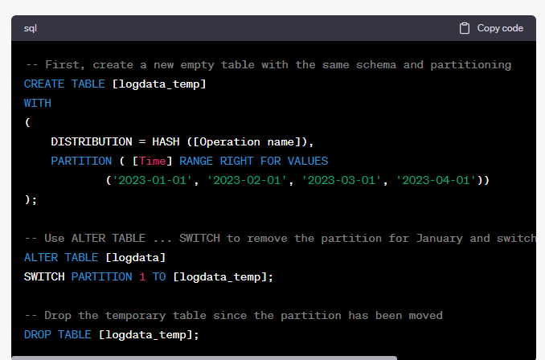

Explanation:

As before, we create a new temporary table called "logdata_temp" with the same schema and partitioning configuration as the original "logdata" table.

The ALTER TABLE ... SWITCH statement is used to remove the partition for January ('2023-01-01') from the "logdata" table. We specify PARTITION 1 to indicate that we want to switch the first partition (which corresponds to '2023-01-01') to the "logdata_temp" table.

The data from the partition is efficiently moved to the temporary table "logdata_temp" through the switch operation. The SWITCH statement is a metadata operation and does not involve physically moving data, making it an efficient way to delete a partition.

Finally, we drop the temporary table "logdata_temp" since the partition data for January has been successfully moved to it. The "logdata_temp" table now contains the data for January that was previously in the "logdata" table.

Keep in mind that partition switching is an advanced feature in Azure SQL Data Warehouse (Azure Synapse Analytics) and requires careful consideration of table structures, partitioning columns, and partition ranges to ensure data integrity and optimal performance. Always test such operations on a test environment before applying them to production tables.

